**Section – 1 –**

**Project Overview**

A leading music-catering company is planning to analyze large amount of data received from varieties of sources, namely mobile app and website to track the behavior of users, classify users, calculate royalties associated with the song and make appropriate business strategies. The file server receives data files periodically after every 3 hours.

**1.1 Fields present in the data files**

**Data files contain below fields.**

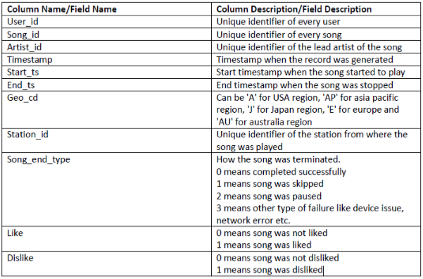

**1.2 LookUp Tables**

There are some existing look up tables present in NoSQL databases. They play an important role in data enrichment and analysis**.**

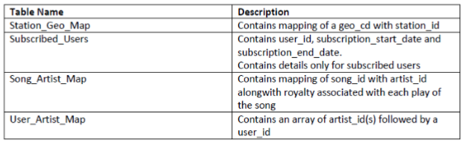

**1.3 DATASET**

1. Data coming from web applications reside in /data/web and has xml format.

2. Data coming from mobile applications reside in /data/mob and has csv format.

3. Data present in lookup directory should be used in HBase.

**Below is the link for same.**

[**https://drive.google.com/drive/folders/0B_P3pWagdIrrMjJGVlNsSUEtbG8?usp=sharing**](https://drive.google.com/drive/folders/0B_P3pWagdIrrMjJGVlNsSUEtbG8?usp=sharing)

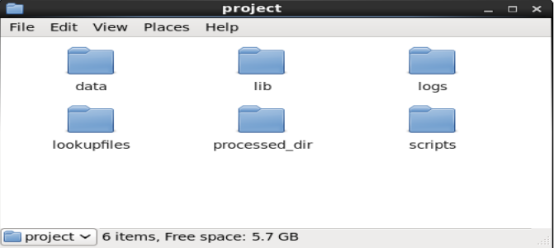

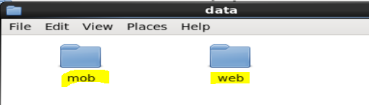

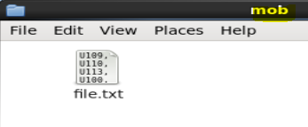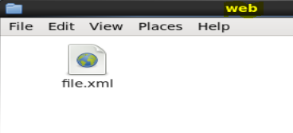

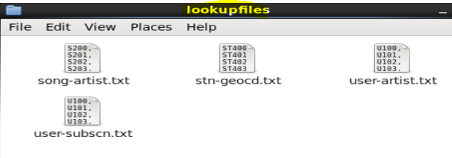

**1.4 Data Enrichment Rules for data enrichment,**

1. If any of like or dislike is NULL or absent, consider it as 0.

2. If fields like Geo_cd and Artist_id are NULL or absent, consult the lookup tables for fields Station_id and Song_id respectively to get the values of Geo_cd and Artist_id.

3. If corresponding lookup entry is not found, consider that record to be invalid.

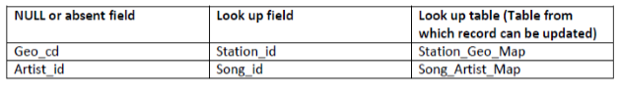

**1.5 Data Analysis (SHOULD BE IMPLEMETED IN SPARK)**

1. Determine top 10 station_id(s) where maximum number of songs were played, which were liked by unique users.

2. Determine total duration of songs played by each type of user, where type of user can be 'subscribed' or 'unsubscribed'. An unsubscribed user is the one whose record is either not present in Subscribed_users lookup table or has subscription_end_date earlier than the timestamp of the song played by him.

3. Determine top 10 connected artists. Connected artists are those whose songs are most listened by the unique users who follow them.

4. Determine top 10 songs who have generated the maximum revenue. Royalty applies to a song only if it was liked or was completed successfully or both.

5. Determine top 10 unsubscribed users who listened to the songs for the longest duration.

**1.6 Challenges and Optimizations:**

1. LookUp tables are in NoSQL databases. Integrate them with the actual data flow.

2. Try to make joins as less expensive as possible.

3. Data Cleaning, Validation, Enrichment, Analysis and Post Analysis have to be automated. Try using schedulers.

4. Appropriate logs have to maintain to track the behaviour and overcome failures in the pipeline.

**1.7 Flow of operations**

A schematic flow of operations is shown below

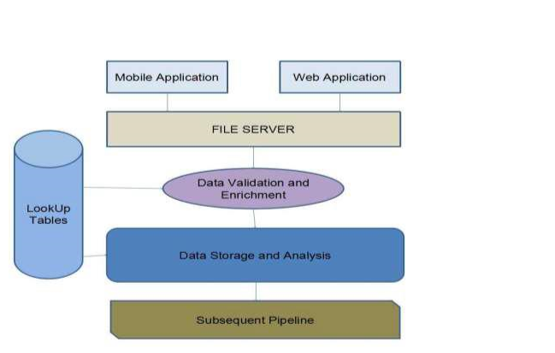

**Section -2** –

**Design of the Project 2.1 Low Level Design**

The following flowchart shows the Low Level design of this project,

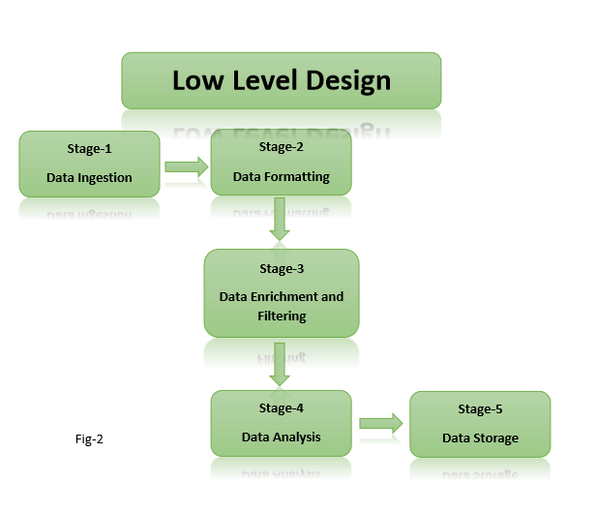

**2.2 High Level Design**

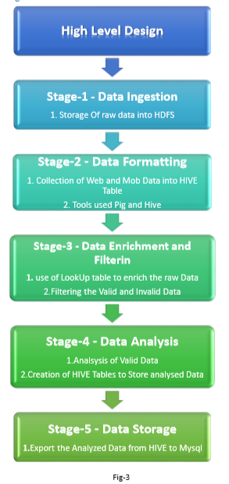

**Section-3-Hadoop Eco-System Implementation**

1. We have created a batch file **“start-daemon.sh”** which starts the daemons such as hive, hbase, Mysql and rest of the all hadoop daemons.

Batch file script,

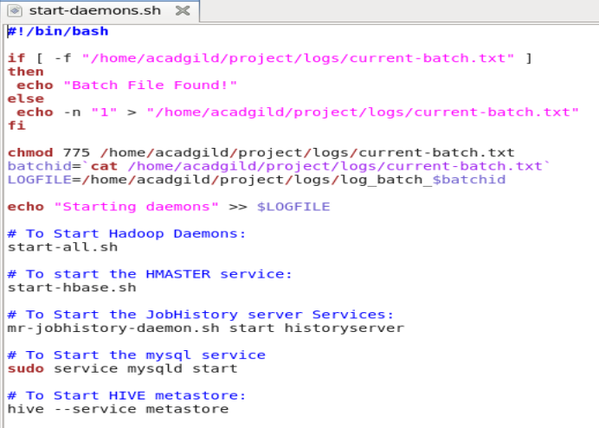

2. **Starting all daemons, sh start-daemon.sh**

As per the batch file script all the hadoop daemons and the Hive, MySql and Hive daemons are started shown in the below screen shot,

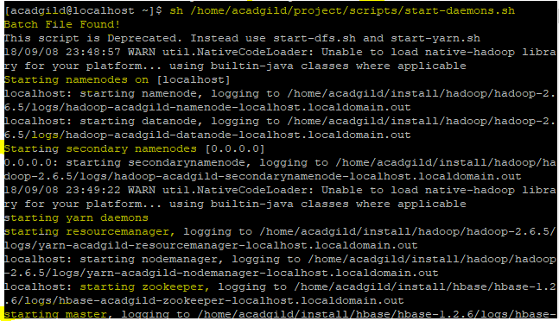

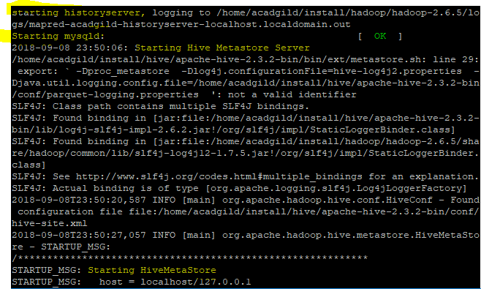

1. We can see the list active services using the jps command, see below screen shot and also Starting the hive metastore created a metastore_db in the location where we desired,

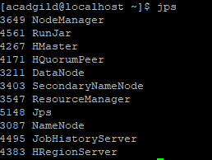



4. The **start-daemon.sh** script will check whether the **current-batch.txt** file is available in the logs folder or not. If not it will create the file and dump value ‘1’ in that file and create LOGFILE with the **current batchid.**

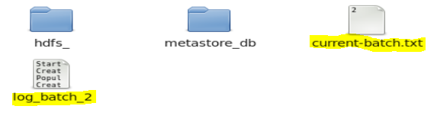

**Section-4 –Data Ingestion, Formatting, Enrichment and Filtering**

**4.1 Stage – 1 – Data Ingestion By using the “populate-lookup.sh”** script we will create lookup tables in Hbase. These tables have to be used in, Data formatting, Data enrichment and Analysis stage

**Lookup Tables**

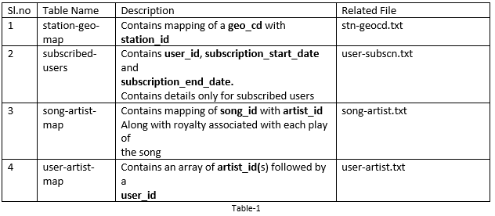

**“populate-lookup.sh” script**

The “**populate-lookup.sh**” shell script creates the above 4 lookup tables in the Hbase and populate the data into the lookup tables from the dataset files.

In the below screen shots, we can see the create-lookup.sh scripts and the following screen shots shows the tables creation and population of the data in the Hbase. Also, the values loaded into the Hbase Tables are also shown, please see the below screen shots.

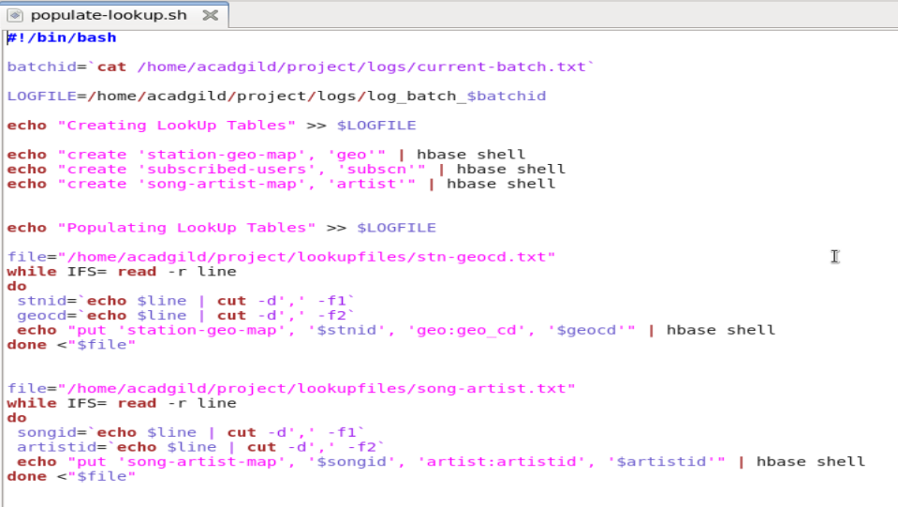

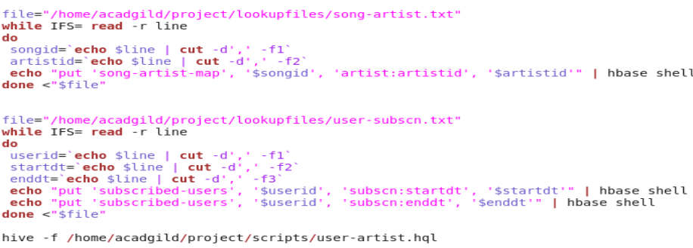

**Run the script: ./populate-lookup.sh**

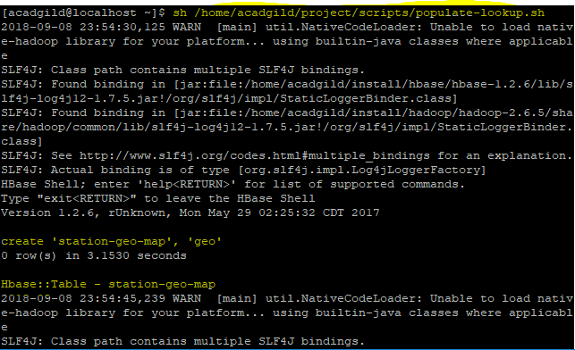

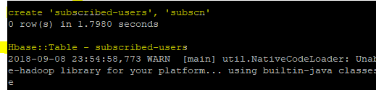

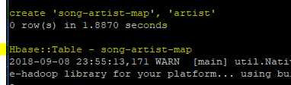







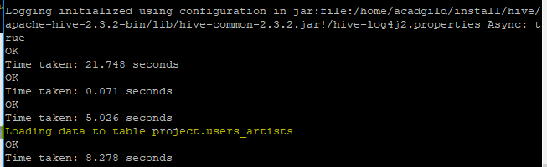

We can see the lookup tables created using the “populate-lookup.sh” in the below screen shot,

Lookup Tables in the hbase shell,

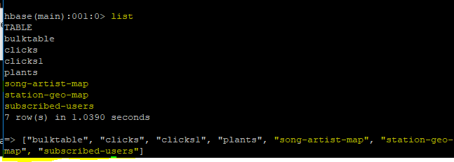

The values loaded in the Lookup tables are shown below,

**song-artist-map**

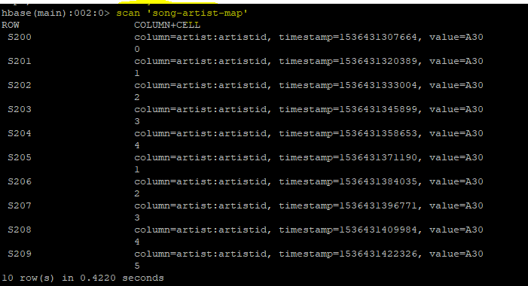

**station-geo-map**

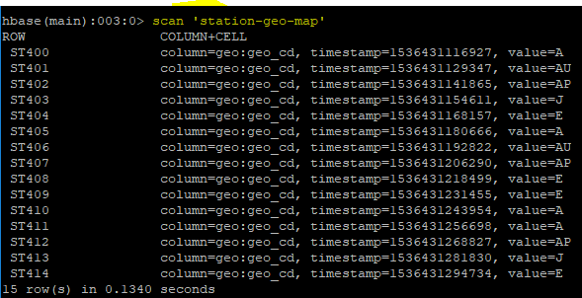

**subscribed-users**

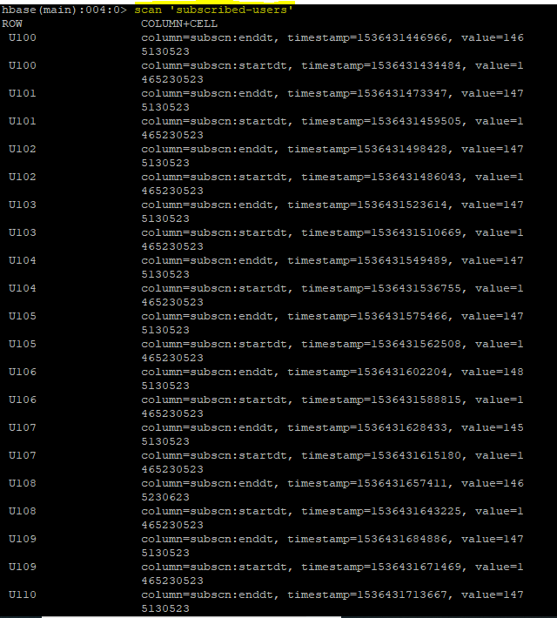

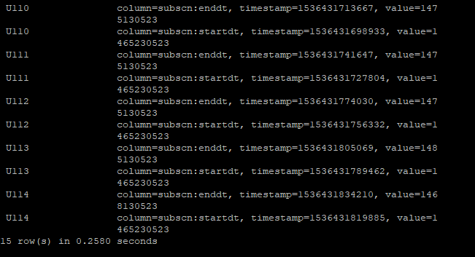

We have successfully created the lookup tables in the Hbase.

The populate-lookup.sh also creates a lookup table **“users_artists”** in the HIVE, loading the data from the **user-artist.txt,** the below screen shot shows that the table has been created in the HIVE.

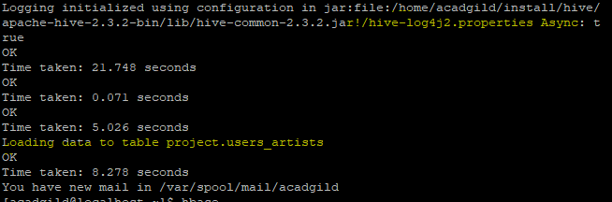

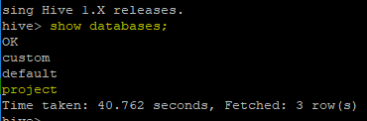



**hive> Select * From users_artists;**

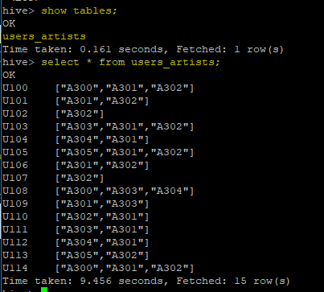

Now we need to link theses lookup tables in hive using the Hbase Storage Handler.

With the help of **“data_enrichment_filtering_schema.sh”** file we will create hive tables on the top of Hbase tables using **“create_hive_hbase_lookup.hql”**

**Creating Hive Tables on the top of Hbase:**

In this section with the help of Hbase storage handler & SerDe properties we are creating the hive external tables by matching the columns of Hbase tables to hive tables.

**Run the script: ./data_enrichment_filtering_schema.sh,**

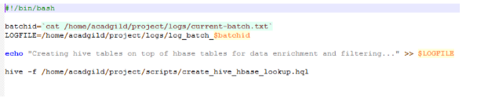

The script will run the **“create_hive_hbase_lookup.hql”** which will create the HIVE external tables with the help of Hbase storage handler & SerDe properties. The hive external tables will match the columns of Hbase tables to HIVE tables.

**create_hive_hbase_lookup.hql**

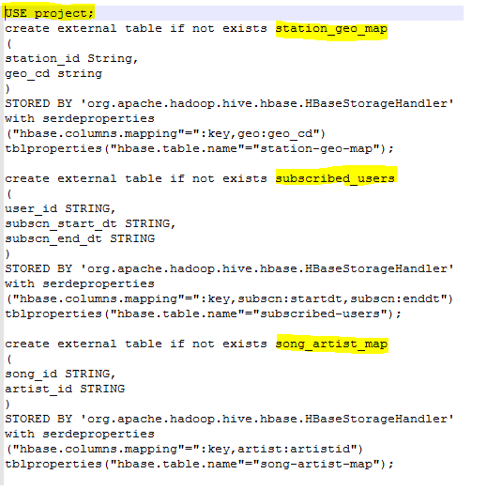

The below screenshot we can see tables getting created in hive by running the **“data_enrichement_filtering_schema.sh file”**

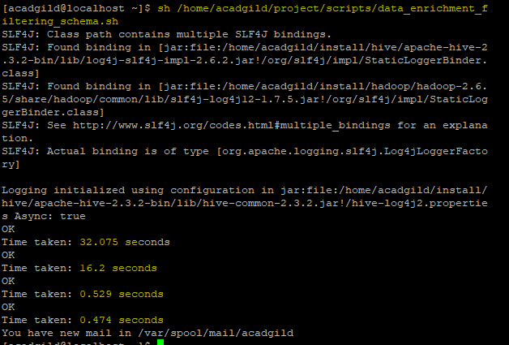

**Hive>Show Tables;**

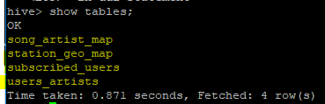

**hive>Select * From song_artist_map**

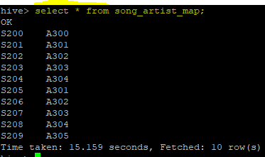

**hive>Select * From station_geo_map**

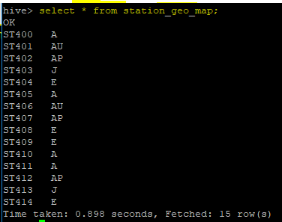

**hive>Select * From Subscribed_users**

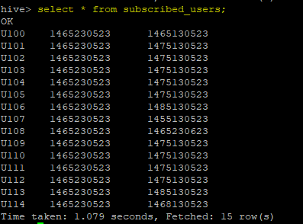

**4.2 Stage – 2 - Data Formatting** In this stage we are merging the data coming from both web applications and mobile applications and create a common table for analyzing purpose and create partitioned data based on batchid, since we are running this scripts for every 3 hours.

**Run the script: ./dataformatting.sh**

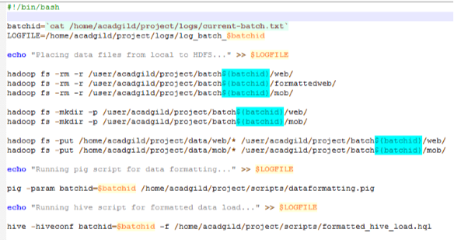

We are running two scripts to format the data. They are:

1. **Dataformatting.pig**
2. **Formatted_hive_load.hql**

Pig script to parse the data from coming from web_data.xml to csv format and partition both web and mob data based on based on batch ID’s

**Dataformatting.pig**

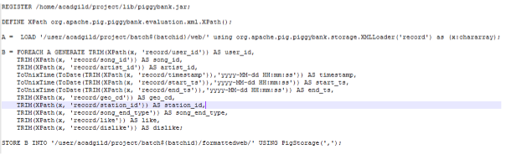

**formatted_hive_load.hql**

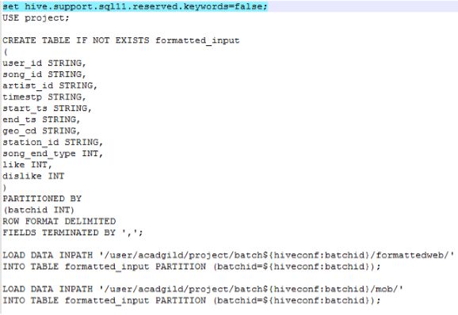

In the below screenshot we can see the data both the scripts in action, first pig script will parse the data and then hive script will load the data into hive terminal successfully.

Pig script successful completion,

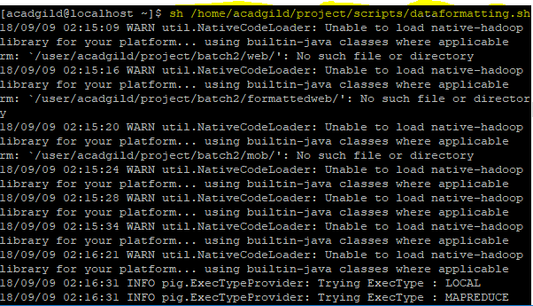

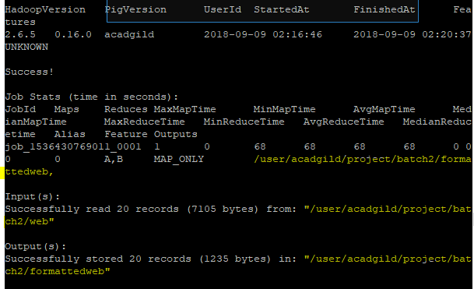

In the above screenshot we can see the **dataformatting.pig** along with the **formatted_hive_load.hql** executed successfully.

**The output of dataformatting.sh script in HDFS folders:**

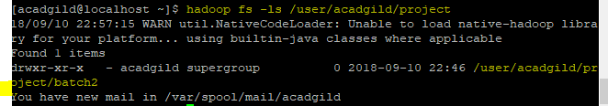

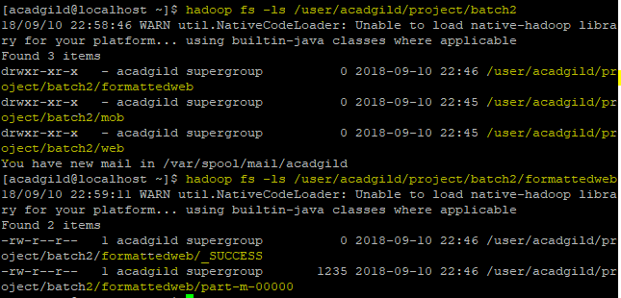

The output of the **formattedweb** data obtained from the **Dataformatting.pig** is shown in the below screen shot,

Command,

**hadoop fs -cat /user/acadgild/project/batch1/formattedweb/\***

